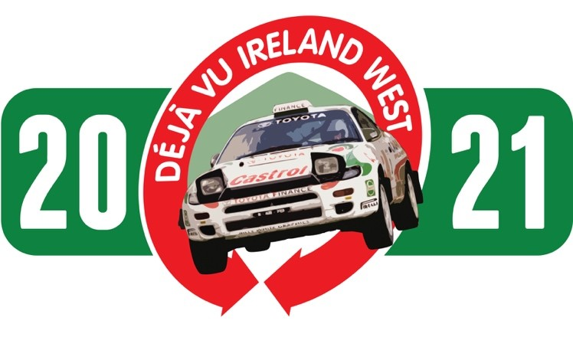
Déjà vu Motorsport Declaration and Indemnity

I wish to drive cars and/or otherwise participate in the above event organised by Déjà vu Motorsport.

I understand the following:-

- That any driving activity may be hazardous and I am voluntarily exposing myself to risk of damage or loss or personal injury by participating in the event.
- That racing is prohibited and the purpose of the day is to showcase classic cars.
- That I must comply with all laws including those relating to speed and appropriate driving.
- Déjà vu Motorsport reserves the right to remove me or anyone accompanying me from the location at which the activity is being provided, if, in the sole discretion of Déjà vu Motorsport, my actions or those of my companion(s) are deemed to be dangerous or detrimental to others.
- Déjà vu Motorsport does not have any control over the competence of other participants
- Déjà vu Motorsport does not provide any insurance cover to any person in respect of any liability which might arise out of the event and that my own motor, third party and public liability insurance (if any) is unlikely to cover me for my losses, liabilities or personal injury. I also waive on behalf of myself and my successors, any claims in relation to the event, including for damages, injury or death sustained on the event, against the event organisers or any other registered participant on the event.

I declare:-
- I am not suffering from any medical condition or disability which might make it unsafe for me to participate in the activity and I am not participating in the activity against medical advice.
- My eyesight (with lenses if to be worn) is up to the standard required for a road driving test in the UK and/or Republic of Ireland
- I hold a current full driving licence for a manual transmission passenger road vehicle for at least one year prior to the date of the activity and that my licence is valid for use within the United Kingdom and Republic of Ireland.
- That that the car entered is suitable and roadworthy for the event having regard to the course and the speeds which will be reached.
- That the use of the car entered is covered by valid insurance as required under the Road Traffic (Northern Ireland) Order 1981.
- That I will not participate in the track day while under the influence of alcohol or intoxicating drugs.
- I shall wear seat belts or harnesses at all times whilst in a vehicle.
- That I will adhere to any rules and/or safety guidance issued to me by Déjà vu Motorsport and acknowledge that while Déjà vu Motorsport will provide guidance, I myself am responsible for the way in which I behave at the event.
Indemnity:
- I hereby agree to indemnify and hold harmless, Déjà vu Motorsport, its employees, officers and agents against all direct and indirect losses, liabilities, costs (including but not limited to legal and other professional costs), charges, expenses, actions, procedures, claims, demands and damages (including but not limited to the amount of damages awarded by a court of competent jurisdiction) that they may face arising directly or indirectly from my conduct or participation in the activity.
- I am __ years of age (if applicable, state "over 17 years").
- I am intending to be a driver/ passenger (delete as appropriate)
- Any indemnity and/or declaration as prescribed by paragraph a above which is signed by a person under the age of 17 years shall be countersigned by that person's parent or guardian, whose full names and address shall be given.
I, the undersigned, hereby declare that I have read and agree to abide by the conditions contained in this document.

Date…………………………….
Full Name
Signature
Address
Venue Name and Date
Vehicle year, make, model and VRN
Emergency Contact Name & Number
Parent/Guardian if applicable

